



**Table of Contents**

**Glossary** **4**

**Test Types** **5**

Smoke Test 5

Development 5

Test Analysis and Maintenance 5

Execution Frequency 5

Regression Test 5

Development 5

Maintenance 5

Execution Frequency 6

**Roles and Responsibilities** **7**

Development Team 7

Manual QA Team 7

QAA CC 7

**Automated Test Usage** **8**

Test Execution Job 8

Automated Testing in CI 8

Smoke Test on Demand 9

Regression Test on Demand 9

Nightly Regression Test 9

Commit Gating 10

Branch Merge 10

Team Merge 11

**Workflow** **12**

Covering New Features in Automated Regression Testing 12

Project Team 12

EIS Competency Centers 12

QAA Task 13

QAA Task Workflow 13

Mandatory Tasks 13

Test Development Tasks 14

QAA Board 14

**Reporting** **16**

Test Analytics 16

Individual Test Report 16

Consolidated Regression Test Report 17

QAA Sprint Report 18

**Appendix 1** **19**

Operational Plan 19

Human Resources 19

Hardware Resources 19



# Purpose

The purpose of this document is to define common strategy vision for EIS R&D and Services of how QAA CC function in a project. The document should be used as basement for any new and existing EIS development and delivery projects.

# Glossary

1. QAA – Quality Assurance Automation
2. QAA CC – EIS QAA Competency Center
3. SUT – System Under Test
4. QAM – Quality Assurance Manual

# Test Types

## Smoke Test

Automated Smoke Test verifies the most critical application function used for all product development branches as acceptance criteria for any new change introduced in a product. More in CRC: [Smoke Testing](https://wiki.eisgroup.com/display/CRC/Smoke+Testing)

### Development

All smoke tests are developed by QAA CC.

### Test Analysis and Maintenance

Smoke Test suite is maintained by Project Development Team in team repositories/branches.

### Execution Frequency

Smoke Test should be executed

1. For regressive verification of SUT health with every new feature, in the feature branch
2. To verify integration with new code when new feature code is merged to team master branch (within branch merge CI process)
3. To verify integration with new code when new code is merged to the central repository from team repository (team merge CI process)

*Notes: Automated Smoke Test can be used by any team member and executed against any SUT build deployed in a cloud or local dev box.*

## Regression Test

Automated Regression Test verifies critical functionality of the most of developed features considered as done and pushed to central code base. More in CRC: [Regression Testing](https://wiki.eisgroup.com/display/CRC/Regression+Testing). Regression Test suite usually contains:

1. Regression test cases for the majority of new features
2. End-to-end tests that validate real world user scenarios
3. Risk-based tests
4. Backward compatibility tests

### Development

All regression tests are developed by QAA CC.

### Maintenance

* Regression Test suite is maintained by QAA CC team in automation team repository according to [test analysis and maintenance process](https://wiki.eisgroup.com/display/IPB/Test+Analysis+Process) on daily basis with 100% analysis rate target

### Execution Frequency

Regression Test should be executed

1. Nightly for the last build from central code repository within scheduled CI pipeline (daily regression test)
2. For regressive verification of SUT health with new massive and risky changes in code/configuration, e.g. sprint platform upgrade (Evergreen), environment configuration update, etc.
3. For SUT release candidates, on demand from project QA manager

# Roles and Responsibilities

## Development Team

1. Develop the EIS Suite according to client requirements
2. Execute smoke tests in feature branches
3. Maintain existing smoke tests to remain compatible the EIS Suite
4. Fix non-functional defects in the EIS Suite to remove impediments for QAA

## Manual QA Team

1. Define acceptance criteria for all new EIS Suite features
2. Develop test cases and end-to-end scenarios according to requirements
3. Create QAA Tasks for test development to cover new features
4. Support Test Scenarios in Jira according to their lifecycle
5. Clarify application defects according to the [Product Issue Clarification process](https://wiki.eisgroup.com/display/IPB/Test+Analysis+Process#TestAnalysisProcess-ProductIssueClarification)
6. Clarify questions from QAA CC related to test scenarios and product functionality

## QAA CC

1. Develop all necessary regression tests according to QAA CC test development process
2. Execute Regression Test suite in CI, analyze and report testing results
3. Support and continuously upgrade CI/CD Test infrastructure
4. Review QAA project code
5. Respond to the project team’s questions and concerns related to automated tests and QAA processes
6. Provide necessary QAA resources and support to delivery project on demand

# Automated Test Usage

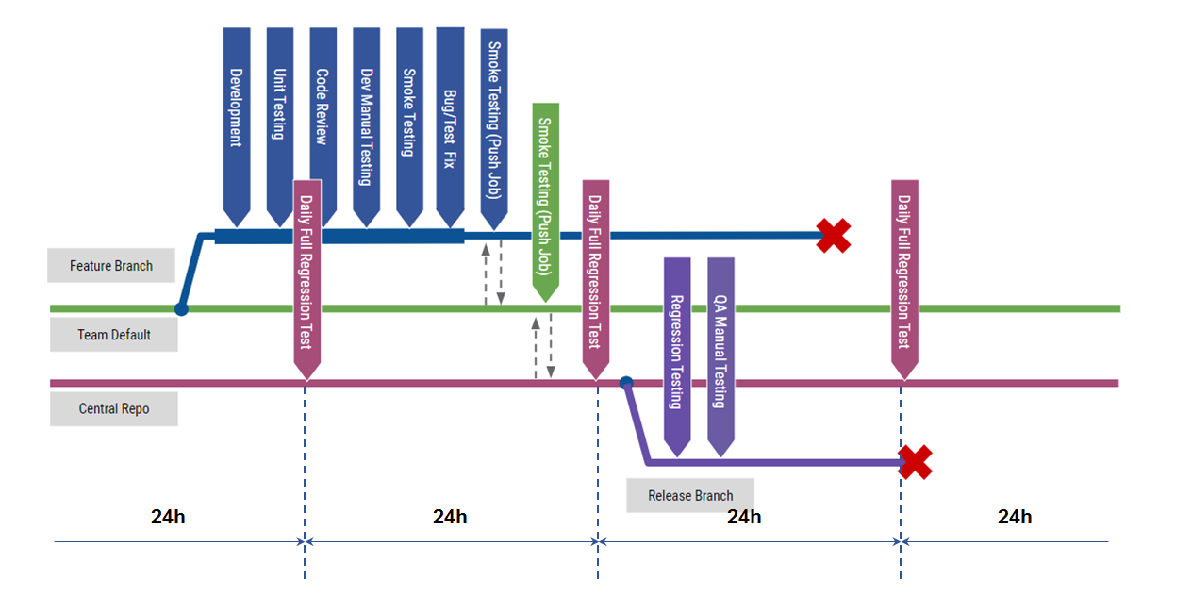

## Test Execution Job

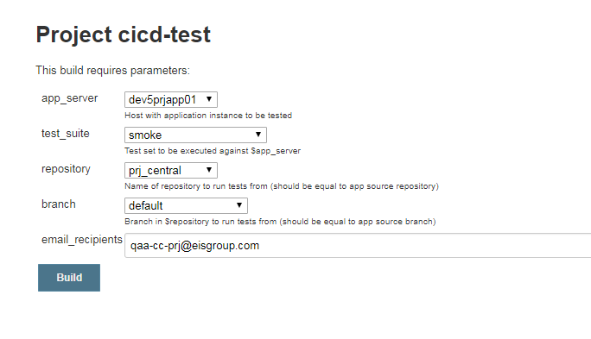

Builds and runs any automated test suite for any application instance built from any branch and deployed in a cloud or local dev box

## Automated Testing in CI

### Smoke Test on Demand

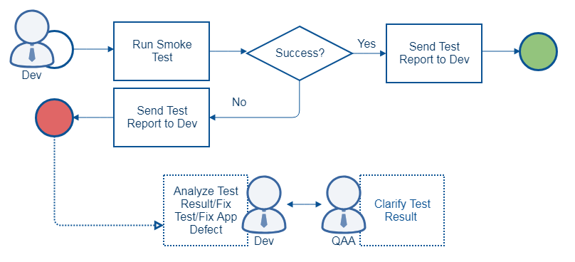

Automated Smoke Test suite being developed in a project is expected to be always run against local and remote application instances before push to common branches to find critical defects in time and should be supported by Developers to fit actual EIS Suite state in all code branches

### Regression Test on Demand

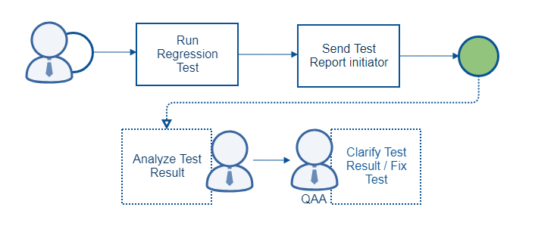

1. Regression Test On Demand
2. EIS Base Upgrade
3. Sprint Release
4. Staging/Demo Environment
5. Any risky changes to be tested

### Nightly Regression Test

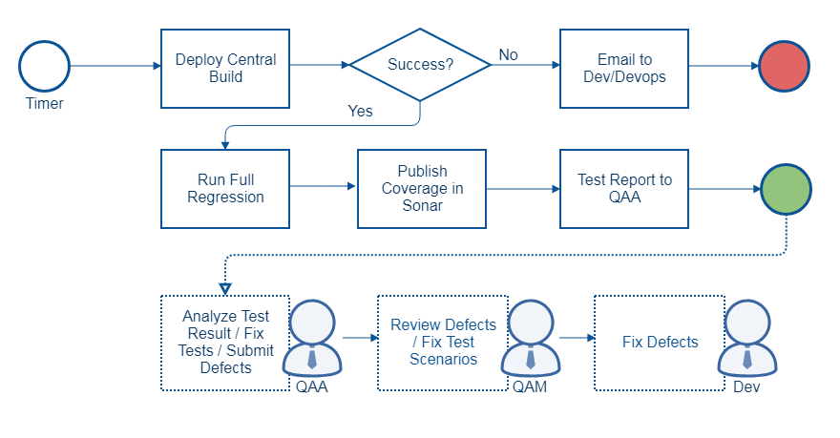

Nightly Regression Test

1. Is run by schedule for the last stable Central build
2. Calculates code coverage been made by full regression run for the particular application build

### Commit Gating

#### Branch Merge

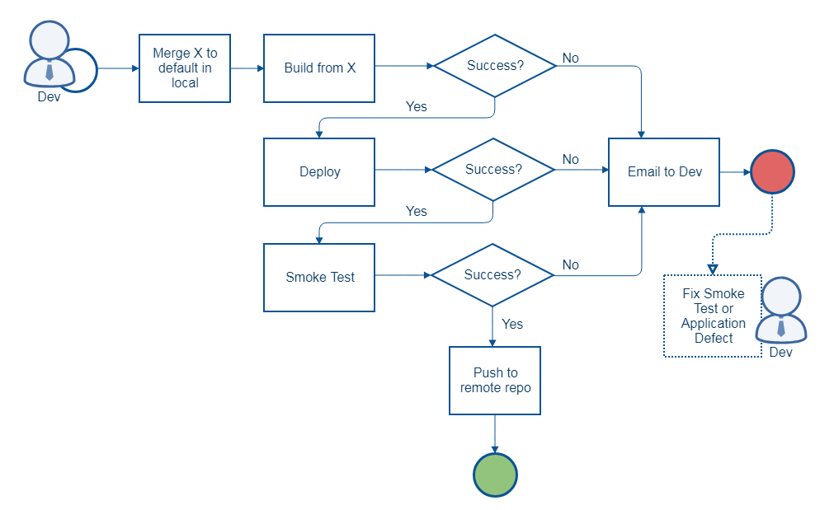

Automated Smoke Test is run by automated CI merge process from dev branches to master branch in all team repositories

#### Team Merge

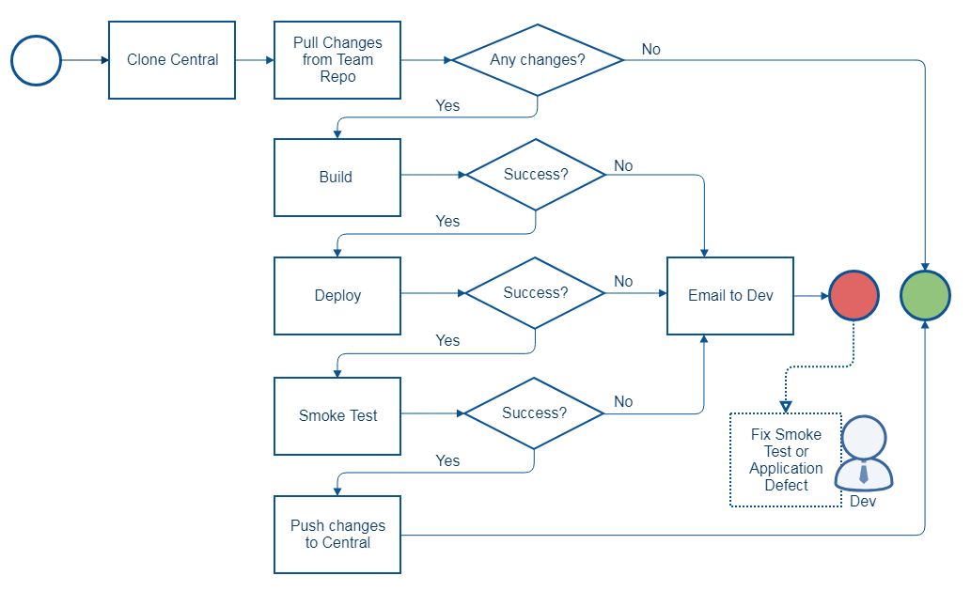

Smoke Test is executed against integration build by automated merge process from team repository to central repository

# Workflow

## Covering New Features in Automated Regression Testing

### Project Team

1. Project Development Team release new features in Sprint X
2. Project QA Manager creates QAA tasks for developed features in Sprint X
3. QAA Team develops tests for new features and adds them to Smoke/Regression in Sprint X+1

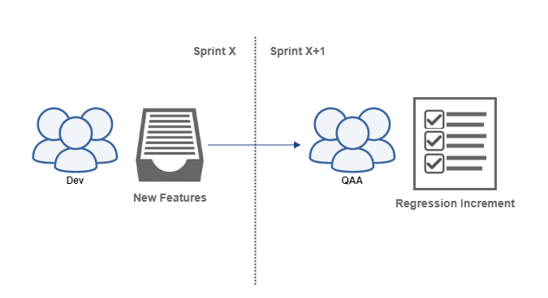

### EIS Competency Centers

EIS Competency Centers developing new features for particular component should collaborate with QAA CC to cover their new features in daily regression cycles following the approach described below:

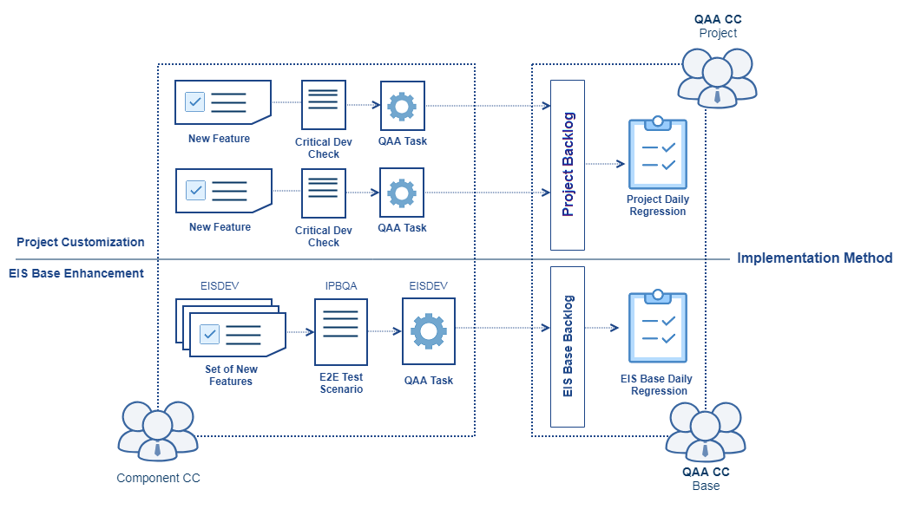

[More in QAA CC Wiki](https://wiki.eisgroup.com/display/IPB/QAA+Collaboration+with+EIS+Competency+Centers)

## QAA Task

The objective of QAA Task is to outline QAA scope in a project. There are Mandatory Tasks and Test Development tasks in QAA Sprint. Mandatory tasks are created on sprint basis by QAA Lead.

### QAA Task Workflow

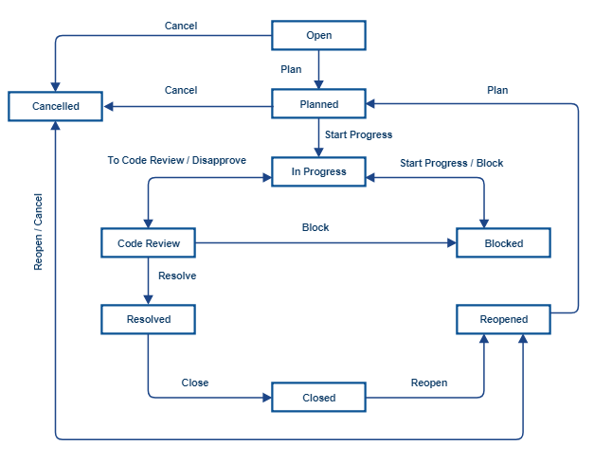

### Mandatory Tasks

|  |  |  |
| --- | --- | --- |
| **Task** | **Priority** | **Notes** |
| Daily Regression Test Analysis and Support | Blocker | Daily analysis of nightly regression results in Test Analytics and fix of regression test suite for next run. Includes all activities related to CI configuration, test environment support, etc. |
| Test Support on demand | Blocker | Assistance provided by QAA to other teams executing Smoke and Regression Test in team branches |
| Mentoring | Critical | Code reviews, demos, training and mentoring for internal and external resources (partners, customer). |
| CI/CD Test Platform Upgrade | Critical | Regular upgrade to the latest versions of CI/CD Test Framework implied by EIS Evergreen approach |
| Team Management | Critical | Planning, retrospective, stand-ups and other meetings |

### Test Development Tasks

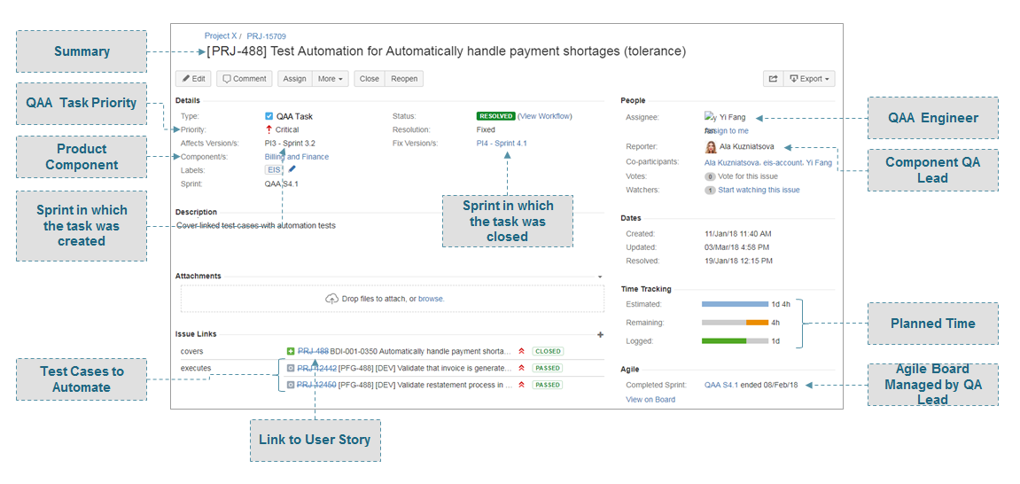

1. QAA Task for test development is created by Project (or Component) QA Lead
2. QAA Task is linked to User Story it covers and Test Cases which should be automated from the User Story (typically it is Critical Dev steps from US acceptance criteria)
3. QAA Task may cover a couple of user stories and/or Test Cases
4. All QAA Tasks are held in QAA Backlog in Jira and managed by QAA Lead together with project QA Lead who defines test development priorities according to business value

## QAA Board

QAA Teams work by scrum. QAA Board should be configured by QAA Lead to track QAA Team progress and outcome.

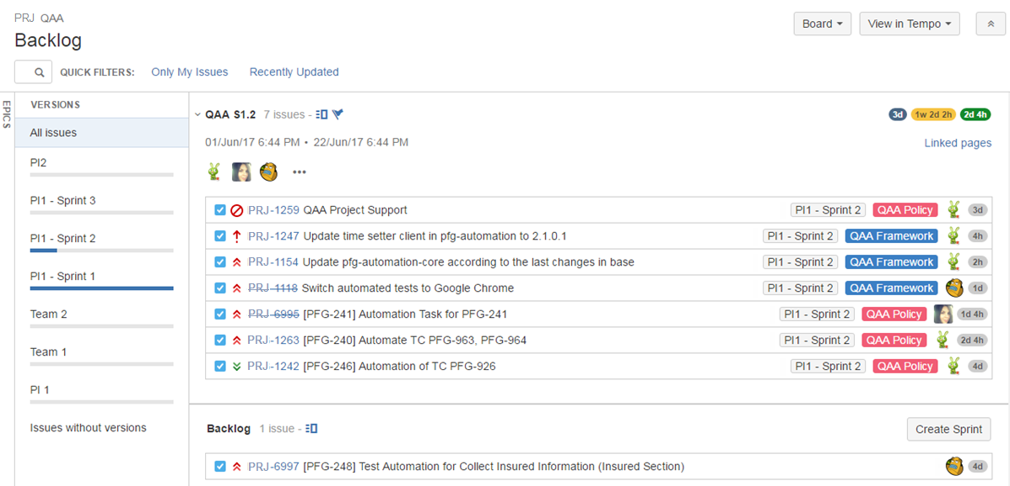

# Reporting

## Test Analytics

Test Analytics - proprietary reporting system being released in docker containers

1. Real-time reporting
2. Visualized analytics and metrics
3. History and statistics
4. Actionable and collaborative results
5. Traceability with defect and test management systems
6. Accelerated support of automated tests

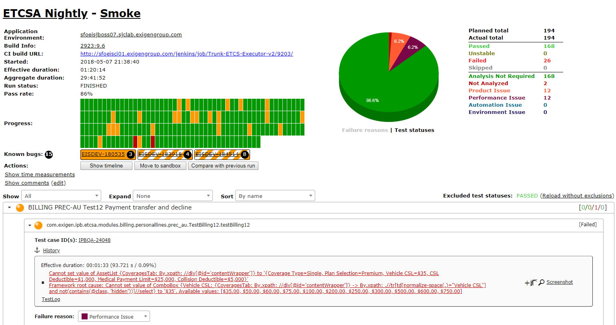

## Individual Test Report

Individual Test Report represents a test suite run in Test Analytics and notifies stakeholders about test execution finish. The report is sent to:

1. A person who initiated the test, automatically by Test Execution Job
2. To [qaa-cc-prj@eisgroup.com](mailto:qaa-cc-prj@eisgroup.com) (email group of Project QAA team)

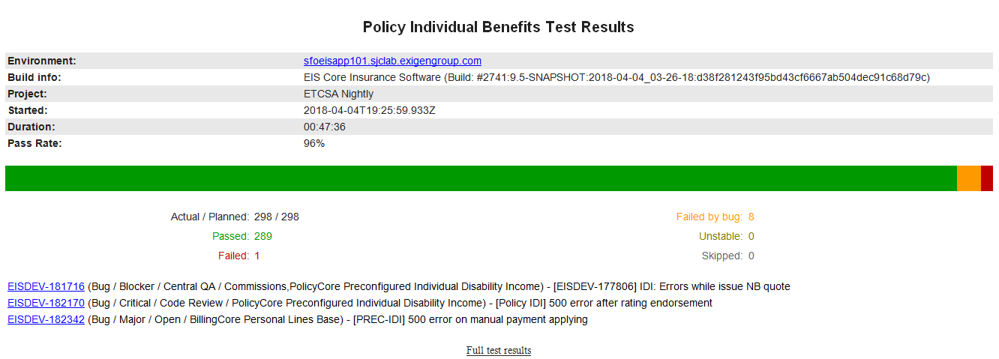

## Consolidated Regression Test Report

Consolidated Test Report is sent to dedicated email group of project participants interested in daily regression test results: [qaa-cc-prj-regression@eisgroup.com](mailto:qaa-cc-prj-regression@eisgroup.com) . The group is shared on project wiki to make anybody able to subscribe.

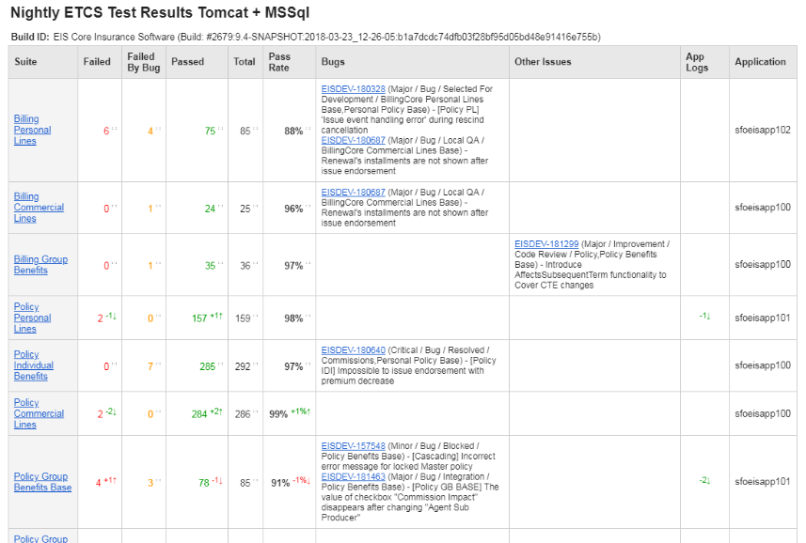

## QAA Sprint Report

QAA Sprint Report is created by QAA Lead, sent to Project management on sprint basis by QAA CC Delivery Manager.

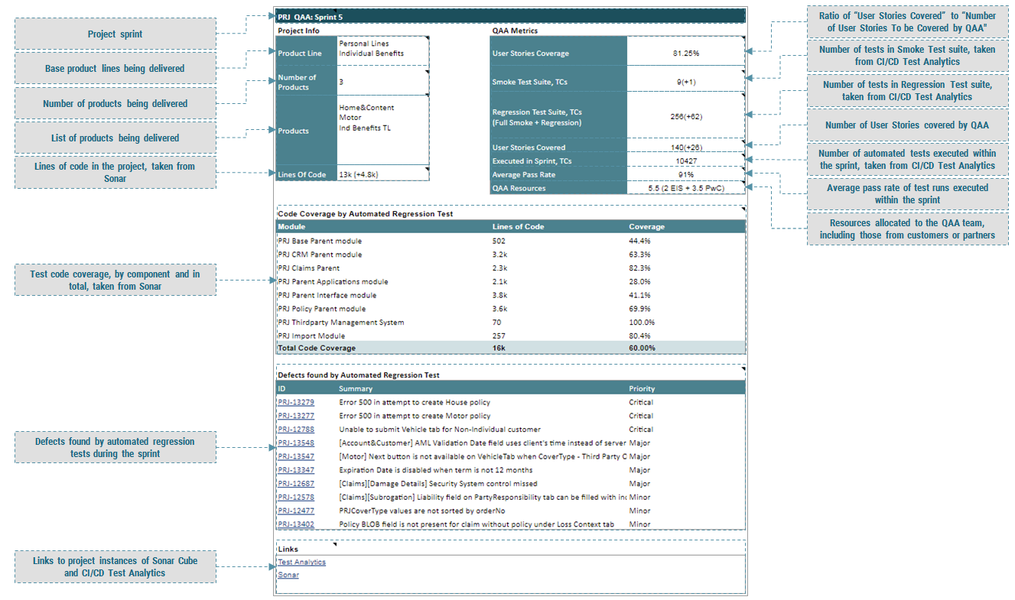

# Appendix 1

The following should be used to share QAA plans to project management at the very beginning of a project

## Operational Plan

|  |  |  |  |  |  |  |
| --- | --- | --- | --- | --- | --- | --- |
| **Epic** | **Task** | **Priority** | **Estimate** | **Status** | **Owner** | **Notes** |
| QAA Project setup |  |  |  |  |  |  |
|  |  |  |  |  |  |
|  |  |  |  |  |  |
|  |  |  |  |  |  |
|  |  |  |  |  |  |

[QAA Project Setup in QAACC Wiki](https://wiki.eisgroup.com/display/IPB/QAA+Project+Setup)

## Human Resources

|  |  |  |  |
| --- | --- | --- | --- |
| Name | Role | Term | Note |
|  | QAA Lead |  |  |
|  | QAA Engineer |  |  |

## Hardware Resources

|  |  |  |  |
| --- | --- | --- | --- |
| Hostname | Role | Capacity | Config |
|  |  |  |  |
|  |  |  |  |
|  |  |  |  |